Outrun the Rays
Rays Melanoma Awareness 5K Run / Walk

DATE: Saturday May 25th, 2019 TIME: 9:00 a.m. LOCATION: Peosta Community Centre

Cost: $25 (includes T-Shirt) prior to May 17th.
Registration fee is $30 on or after May 18th. T-shirts are not guaranteed with late or same day registration.
Registration packets may be picked up from 8:00 – 8:45 a.m. at the Peosta Community Centre on the day of the race.
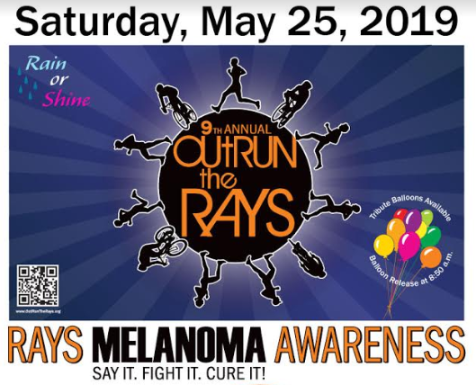
~Rain or Shine Event~

Prizes
Awarded to the top three places of each age group.

Registration, Donation, and Merchandise Purchase
On-Line: Find links at OutrunTheRays.org
or
Mail: Complete this form & mail with payment to:
Outrun the Rays
c/o Jack O’Brien
301 Oak Forest Dr.
Epworth, IA, 52045

5K Run / Walk Entry Form

First Name:
Last Name: |  | Phone:
Email: |  | Date of Birth:
Address: |  | Gender:
City, State, Zip: |  | Shirt Size (circle) | YS YM YL S M L XL XXL(+$2)
Liability Waiver: In consideration of your acceptance of this entry, I hereby, for myself, my heirs, executors, & administrators, waive any and all rights and claims for damages I may have against the Peosta Community Centre, City of Peosta, and any sponsor or contributor to this event and their representatives, successors & assigns for any and all injuries suffered by myself in said event. I assume all the risks associated with running or walking in this event, including but not limited to falls, contact with other participants, the effect of weather, traffic and the condition of the road, all such risks being known and appreciated by me. I attest & verify that I have full knowledge of the risks involved in this event & I am physically trained to participate in this event. By signing below, the individual/guardian accepts and agrees to terms listed above.
Signature: ______________________________________________________ Date:_______________________________

Parent’s Signature____________________________________________________________________(required if under 18)

Additional Shirts
$10 each Shirt ($12 for XXL)
Size | Qty | Line Total
 |  | $
 |  | $
 |  | $
 |  | $
 |  | $
Shirts Total: |  | $

Payment Amount

 | Amount
Race Registration | $ | $25  ($27 for XXL Shirt)
Shirts  Total | $ | From Table at left
Additional Donation | $ | Please consider an additional donation
Total: | $
Please make check payable to: Outrun the Rays

